A Call for Conference Exhibitors for the

with the theme of:
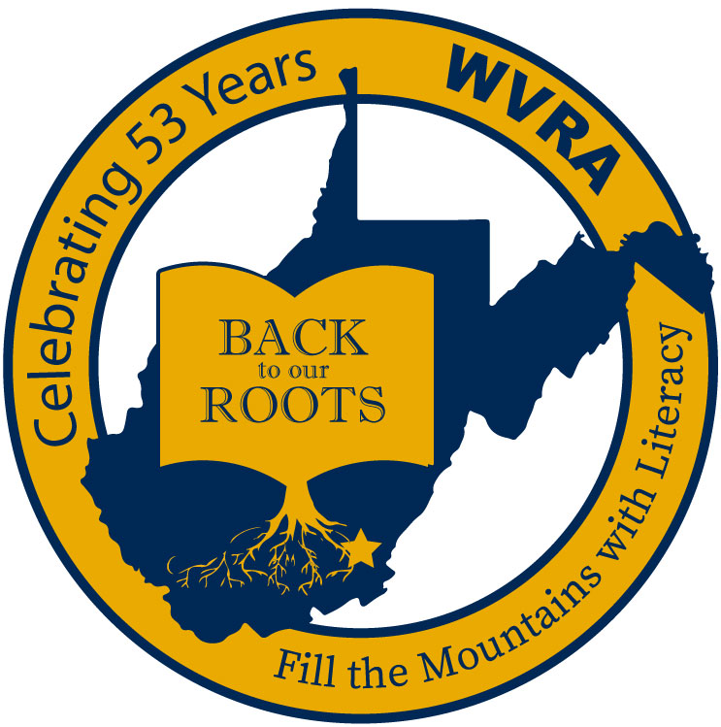

WVRA 65th Conference
November 18-19, 2021

At the Greenbrier Resort
White Sulphur Springs, West Virginia 24986

Exhibitor Registration Deadline-October 22, 2021

Reasons to Purchase Exhibit Space

- The West Virginia Reading Association, (WVRA), is the oldest professional organization in West Virginia committed to literacy instruction in the Mountain State.
- During the annual WVRA Conference, over 500 educators from all over West Virginia and several surrounding states will go through the Exhibit Hall.
- This conference provides an opportunity for vendors to showcase some of their new and exciting materials.
- Conference attendees say they learn valuable information in the Exhibit Hall to improve instruction in their classroom because they are provided the opportunity to see and learn about the latest instructional materials, technology and services from the vendors. As a result, some conference attendees will purchase items to use in their classrooms during the conference.
- Higher Education vendors have an opportunity to recruit educators for undergraduate or graduate degree programs.

Conference Overview
Literacy is an all-encompassing term that includes reading, writing, listening, and speaking. Students need high quality instruction in all these areas to be successful in and out of the school environment. Reading and writing are parallel activities and best practices have revealed that teaching the two together is beneficial instructionally for students. Incorporating listening and speaking enhances the entire literacy experience for students.
In a time where students are easily over-stimulated with various technologies, the simplicity of enjoying the written and spoken word can often times be overlooked. West Virginia is known for its rich history of sharing traditions from one generation to the next through the basic processes of reading, writing, speaking, and listening. Getting “back to our roots” in the classroom and teaching students through effective literacy instruction will ensure that our students will be successful in life.
- WVRA was founded to instill a love and respect for reading in our state
- Reading is emphasized, but best practices suggest that writing, listening and speaking are best taught in conjunction with reading
- The relationship between reading and writing is linear—better readers make better writers, better writers make better readers
- Focus on intertwining the reading and writing processes to enhance our students’ reading AND writing abilities (literacy)
- Incorporate all components of literacy across content areas
- Reading and writing are fundamental and necessary skills for those students on-track for attending college AND those on a career path after high school
Proposal Evaluation Criteria

- Strongly connects to the conference theme – Back to Our Roots: Fill the Mountains with Literacy
- Incorporates technology, intergenerational, civic, or higher education partnerships.
- Adapts instruction for students with diverse and special needs.
- Integrates reading/English language arts instruction in all content areas.
- Integrates reading and writing instruction
- Excluded from selection are (1) incomplete proposals, and/or (2) proposals that promote commercial materials, programs, and/or professional consultants.
WVRA 2021 Annual Conference
Exhibit Registration Form
November 18-19, 2021
The Greenbrier, 300 W. Main Street
White Sulphur Springs, WV 24986

WVRA Tax Exempt Number: 824664057

Company Name and Address: _________________________________________________
_________________________________________________________________________

Representative’s Name/Address________________________________________________
__________________________________________________________________________

Phone ______________________ Fax _____________________________________

E-Mail ________________________________________________________________

Number of tables at $250.00 per table ___________ Amount enclosed: $______
Electricity needed: Yes ________ No______

Phone/Internet: Arranged through The Greenbrier Sales Office by the vendor.
Special Needs: ___________________________________________________
________________________________________________________________

Door prize donation to WVRA: Yes_________ No ________
Description (optional): _________________________________________________________

Names for nametags: ______________________ _______________________
______________________ _______________________

If you are willing to sponsor an author luncheon, keynote or conference dining experience, please contact Dr. Shelly Ratliff (shelly.ratliff@glenville.edu) at 304-677-9883.

Please Note:
To guarantee exhibiting space, all fees must be paid to the
West Virginia Reading Association on or before October 23,
2020. Exhibiting space will not be guaranteed until table
Please indicate below the number of years your company has exhibited at the WVRA Conference.

______ years.

fees are paid in full.

Return this form and check made payable to: WVRA to:

Frances Horton
FAX: 304-736-3297
6019 Pullen Ct. E-mail: franread@aol.com
Barboursville, WV 25504 Phone: 304-736-5839

Table fee: $250.00 per table for Thursday and Friday.

GENERAL VENDOR INFORMATION

Conference Date: November 18-19, 2021

Place: The Greenbrier – Exhibit Hall

Tables: 8' x 30" (Electricity by Request)

Technical Needs: Phone/internet must be arranged by vendor through The Greenbrier sales office at
(304-536-7837)
WVRA is not responsible for this additional service.

*Exhibit Set Up: 2:00 p.m. - 5:00 p.m., Wednesday, Nov. 17
*Exhibit Hall Schedule 8:00 a.m. - 5:00 p.m., Thursday, Nov. 18
7:00 a.m. - 2:30 p.m., Friday, Nov. 19
*Exhibits Dismantled: By 5:00 p.m. on Friday Nov. 19
* Times listed are tentative – check nearer to conference date

Check at the Service Entrance of the Greenbrier Hotel for directions to Exhibit Hall loading and unloading area.

Tables will be labeled with company names.

Door prizes are to be given out by exhibitors at their table or given to Hospitality Chair: Teresa Brown for distribution at the closing session.

Exhibit fees cannot be returned after October 23, 2021.

MERCHANDISE FORWARDING:
All packages should be mailed to:

Guest Name & Company, WVRA Exhibits
Attention: Bibbs Tolley, Porter
300 West Main Street
White Sulphur Springs, WV 24986

